Solution Architecture Specification
Activate AI Apps Platform
Recommended Architecture
Product Name: Activate AI Apps Platform (component of the Activate AI Platform)
Architecture Option: Recommended target architecture, roadmap and delivery plan for the Apps Platform
Prepared for: Activate Interactive – product leadership
Prepared by: Activate Interactive Pte Ltd
Release: 1.6 (Draft for review) – gateway discovery and management interface, tenant-scoped gateway configuration embedded in the Admin console, build-time and run-time credentials issued by the gateway (additions † from the RESPONSIBLE-AI-ENTERPRISEREADY roadmap review (2 October 2026), R6; Appendices A–B updated by addition only); 1.5: runtime-to-gateway request segments and signed context token; Phases 0–4 follow the Activate team’s revision in Overall Roadmap v1.2 (generic knowledge and analytics tools in Phase 1, NEA port in Phase 4); 1.4: Workflow Agent and Agent Workflow interoperability (Phase 4); 1.3: as-built RAG and analytics as generic tools; 1.2: bespoke AI app onboarding (no GPU or model hosting); 1.1: phased roadmap and resource plan
Date: 2 October 2026
Author(s): Joseph Stephen, Solutions Architect
Baseline: AI Gateway Recommended Architecture v1.2 (parent document); product vision brief (1 Oct 2026)

Document References
Ref | Document | Use in this specification
R1 | AI Gateway Recommended Architecture v1.2 | Parent architecture: platform core, AI Gateway, editions, roadmap, pricing
R2 | activepieces-main v0.92.0 source (reviewed 2 Oct 2026) | Workflow builder capabilities and CE / EE boundary
R3 | NEA_Local_POC architecture v3.0 | Reference bespoke AI app to onboard
R4 | AI Gateway as-built specification v1.0 | Reusable chat UI, applications model and agent loop design
R5 | Digital Patient Solution Product Architecture Specification v6 | Document template
R6 | RESPONSIBLE-AI-ENTERPRISEREADY PROXY_MANAGER_ENTERPRISE_DESIGN.md and ROADMAP.md (2 Oct 2026) | Control-plane integration contract, settings hierarchy and guided configuration consumed by the Apps Platform

Table of Contents

Right-click the table of contents and choose Update Field if page numbers are not shown.

Solution Architecture Specification – Part I

1 Context

1.1 Overview
Business and technical domain, problem, need, and a general description of the solution.
Objective: the AI Apps Platform lets customers build, publish and run AI applications – templated chat apps, templated agentic apps, a chat-app builder, an agent builder (LangGraph), multi-agent apps with an orchestrator and chat interface, and a workflow builder that runs with or without a chat interface. Apps are published as web apps (installable as PWAs on mobile). The platform also onboards bespoke AI apps (“bring your own app”, e.g. the NEA Local POC) so that they can use the platform core services and AI Gateway services; bespoke apps and their models keep running in their own environment. The platform does not host GPU-driven models.
This document specifies the Apps Platform in detail. It inherits the platform core (tenancy, Microsoft Entra ID, audit, observability, metering), the deployment modes and the commercial model from the parent AI Gateway Recommended Architecture, and relies on the AI Gateway – or Gateway Essentials in the Apps edition – for every call to third-party models, knowledge, tools and external agents.
Key objectives:
- Business teams publish a governed AI app from a template in under a day, without code.
- Developers extend the same apps in code (LangGraph, TypeScript pieces, SDK) without leaving the platform.
- Every app follows one lifecycle: build → ground → evaluate → approve → publish → operate → improve → retire.
- Bespoke AI apps are onboarded to use the platform core (sign-in, tenancy, audit, observability, metering) and AI Gateway services, while they keep their own hosting and models.
- Apps scale from a 100-user department to 1,000 users or agents per tenant without redesign.

1.2 Solution Options and Rationale
Decision | Recommendation | Alternatives considered | Rationale
App types | Five app types on one registry: chat, agentic, multi-agent, workflow, and onboarded bespoke apps | Separate tools per type | One lifecycle, one publish path, one billing model
Agent framework | LangGraph open-source library inside an Activate agent runtime, with a PostgreSQL checkpointer | LangGraph Platform (commercial); CrewAI; Activepieces agents | Durable state, interrupts for HITL and streaming in the MIT library; avoids LangGraph Platform licensing; Activepieces MCP and knowledge tools on agents are Enterprise-only
Workflow builder | Activepieces Community Edition (MIT), embedded; AI steps through a custom “Activate AI Gateway” piece | Activepieces Enterprise; n8n; build own | 280+ connectors and a mature builder; Enterprise features replaced by the platform core (licence track separate)
App delivery | Next.js app shell renders any published app from its manifest; installable PWA; optional embed widget | Generate separate code per app; native mobile apps | No per-app build pipeline; one security and accessibility baseline; PWAs avoid app-store releases
Knowledge | Knowledge adapters: AI Gateway RAG (default), Bedrock Knowledge Bases or OpenSearch, Activepieces library (limited) | Activepieces library only | Activepieces library is pgvector-only, upload-only, project-scoped and cannot embed via the gateway (section 2.5)
Bespoke AI app onboarding (BYOA) | Integration, not hosting: the app registers with the platform and uses platform core services (Entra ID sign-in, tenancy, audit, observability, metering) and AI Gateway services (LLM proxy, RAG, MCP, A2A) through the SDK and APIs. The app and its bespoke models stay in the owner’s environment; no GPU or model hosting | Host bespoke app containers and GPU model backends on the platform | Bespoke apps get governance, observability and chargeback without the platform taking on GPU capacity or model operations
Model access | Only through the AI Gateway public interfaces (OpenAI-compatible, MCP, A2A) | Direct provider SDKs in apps | Governance by default; works with Gateway Essentials or a customer-mandated gateway

1.3 Context Diagram(s)
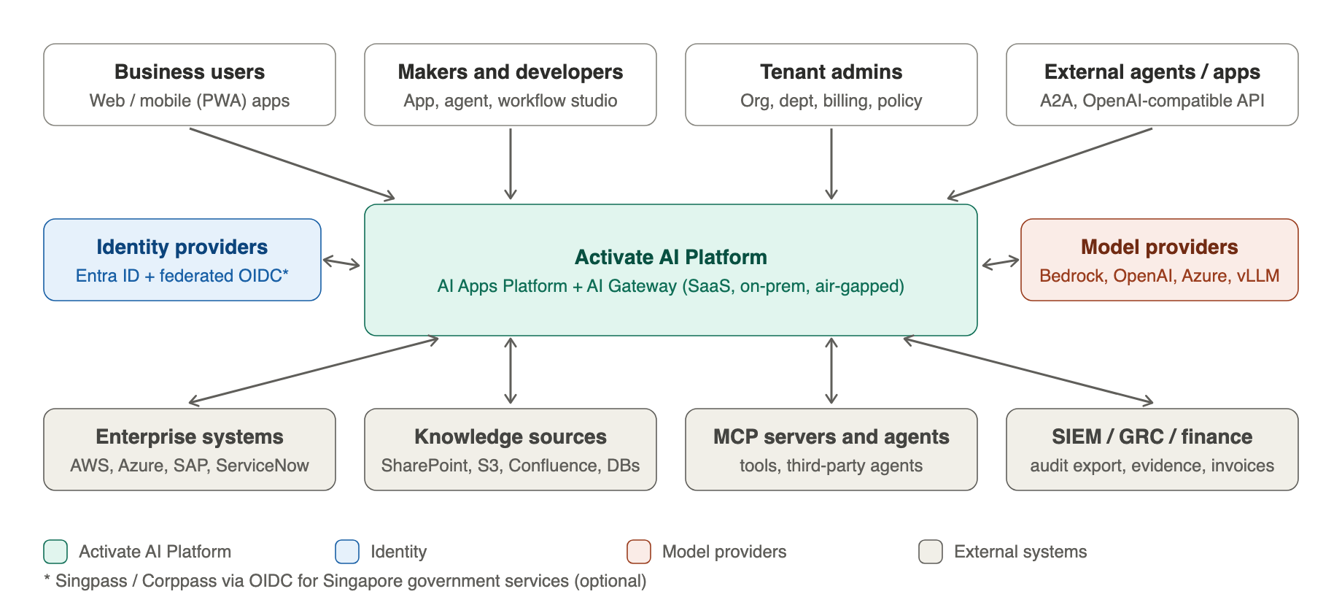
Figure 1 – Activate AI Platform context (Apps Platform is the build-and-run half)

1.4 User Interfaces
Interface | Users | Description
Published apps | End users | Chat, agentic, multi-agent and workflow apps as responsive web apps, installable as PWAs; embed widget for intranets and portals
App Studio | Makers | Template gallery, chat-app builder (prompt, persona, knowledge, tools, theme), preview, evaluation results, publish request
Agent Builder | Makers, developers | Graph editor for LangGraph agents (nodes, tools, memory, interrupts) with a code mode and Git sync
Multi-agent designer | Developers | Orchestrator with local sub-agents and remote agents discovered through A2A
Workflow Builder | Makers | Embedded Activepieces builder with Activate pieces; triggers include chat, form, webhook, event and schedule
Approvals | Department approvers | Review evaluation results, Responsible AI checks and cost estimate; approve or reject a version
App operations | App owners, tenant admins | Usage, cost, feedback, incidents, HITL queues, version rollback, retirement
Gateway configuration (embedded) | Tenant admins, department admins | Tenant-, department- and app-scoped gateway settings (models, budgets, routing, guardrails, keys) rendered from the gateway’s capability manifest; inherited values and locks shown; guided by the settings catalogue and configuration copilot

1.5 Functionality
App type | What makers can do | Built on
Templated chat apps | Pick a template (HR policy, IT helpdesk, knowledge assistant, citizen enquiry, sales enablement), bind knowledge and tone, publish | Chat runtime + template library
Chat app builder | Configure system prompt, persona, model profile, knowledge sources, MCP tools, starter questions, theme, language, guardrail profile | Chat runtime; applications model from the as-built gateway
Templated agentic apps | Case triage, report authoring, procurement assistant, document review, incident responder – each with tools and human checkpoints | Agent runtime + templates
Agent builder | Design a LangGraph graph (plan, tool, review, approve nodes), attach tools from the MCP registry, set memory and interrupts | Agent runtime
Multi-agent apps | Supervisor agent routes work to specialist sub-agents and remote A2A agents, merges results, exposes one chat interface | Orchestrator + A2A client
Workflow apps | Automations with or without chat: triggers, 280+ connectors, AI steps, approvals, schedules; publish a workflow as an app or a chat command | Activepieces CE + Activate pieces
Bespoke AI app onboarding | Register an existing bespoke app; connect it to platform sign-in, tenancy, audit, observability, metering and AI Gateway services via SDK and APIs; the app and its models stay where they run today | Onboarding service + SDK
Publishing | Versioned, immutable releases; custom domain; PWA manifest and icons; access policy (internal, specific groups, public) | App registry + app host

1.6 Data
Data | Examples | Handling
App definitions | Manifests, prompts, graphs, flows, themes, versions | Tenant-scoped; immutable per version; Git export
Runtime state | Conversations, agent checkpoints, workflow runs, HITL tasks | Tenant-scoped; retention per app; PII redacted before model calls
Knowledge bindings | References to gateway RAG sources, Bedrock KB IDs, OpenSearch indexes | Only references stored in the Apps Platform
Connections | OAuth tokens and keys for SaaS and enterprise systems | Vaulted (KMS / Vault); scoped to app
Onboarded app records | Registration, endpoints, identity client, gateway virtual-key reference, telemetry settings | Tenant-scoped; the platform holds no app images or model weights
Feedback and evaluation | Ratings, test sets, evaluation scores | Per app version

1.7 Integration Interfaces
Interface | Direction | Purpose
AI Gateway (OpenAI-compatible, MCP, A2A, RAG) | Outbound | All third-party model, tool, knowledge and remote-agent calls
Platform core APIs | Outbound | Identity, authorisation, audit, metering, entitlements
Integration Hub | Outbound | Application-to-application calls to AWS, Azure, SAP, ServiceNow, REST
App APIs and webhooks | Inbound | Invoke a published app or workflow from other systems
A2A server | Inbound | Published agents can be called by other agents (through the gateway)
Telemetry SDK | Inbound (from onboarded bespoke apps) | Traces, usage and audit events from bespoke apps
AI Gateway discovery and management (well-known document, capability manifest, management API with token exchange) | Outbound | Discover gateway capabilities at run time; render or embed tenant-scoped gateway configuration in the Admin console; obtain build-time and run-time credentials for apps

1.8 Usage Profile and Sizing Assumptions
Parameter | GA 1.0 (Jun 2027) | GA 2.0 (Oct 2027)
Published apps per tenant | 10–20 | 50–100
Users per tenant | 100 | 1,000
Concurrent agent runs per tenant | 50 | 1,000
Workflow runs per day per tenant | 5,000 | 50,000
Onboarded bespoke apps per tenant | 1 | 5
App page load (p95, CDN-cached shell) | < 2 s | < 1.5 s
First token in chat (p95, excl. model time) | < 300 ms platform overhead | < 200 ms

1.9 Editions and Dependency on the AI Gateway
Edition | Apps Platform | Model, knowledge and tool path
Suite | Full | Full AI Gateway
Apps edition | Full | Gateway Essentials (LLM proxy, baseline guardrails, metering); recommended addition: basic knowledge search (open item)
Apps edition with customer-mandated gateway | Full | Customer’s OpenAI-compatible gateway via the external gateway adapter; governance of model calls stays with the customer

Solution Architecture Specification – Part II

2 Specifications

2.1 Components and Deployment Diagram(s)
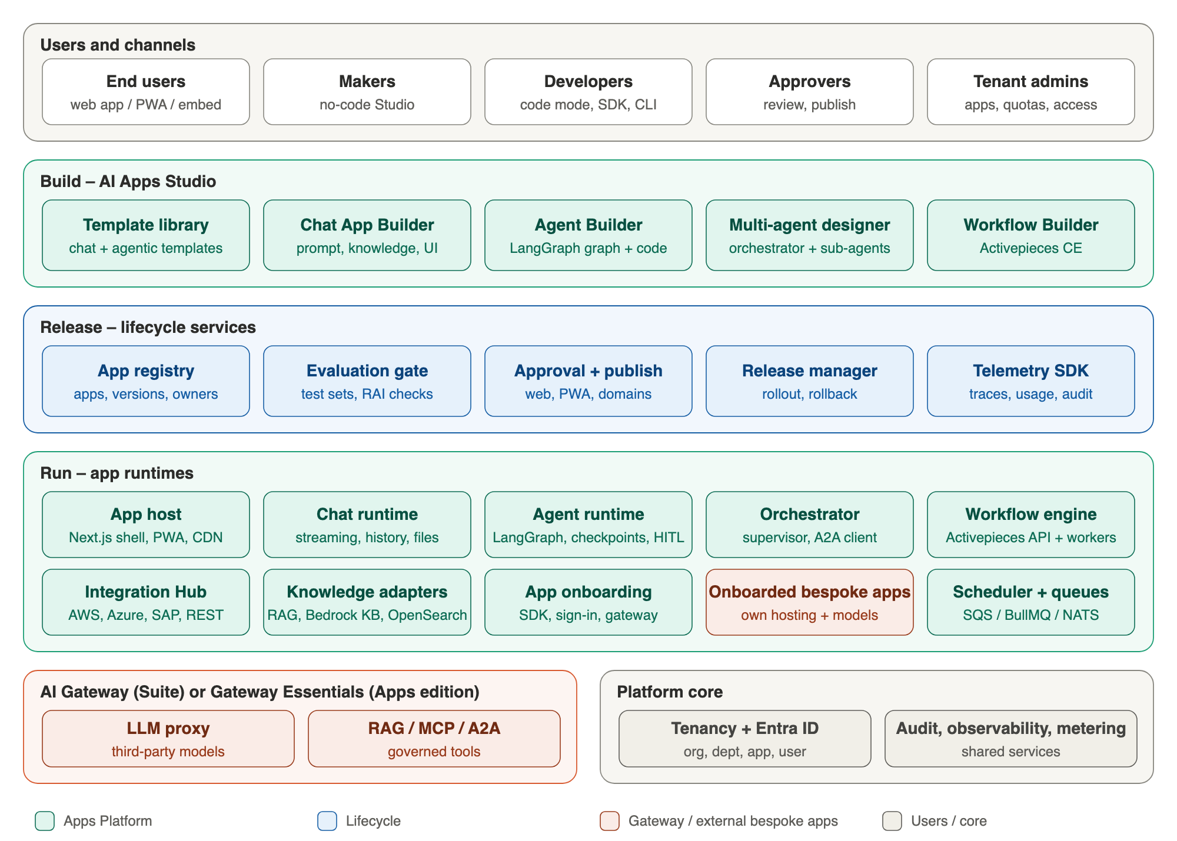
Figure 2 – AI Apps Platform logical architecture: build, release, run

Key Design Decisions
- Manifest-driven apps: every app version is a signed manifest (type, prompts, graph or flow reference, knowledge, tools, model profile, guardrail profile, UI, access policy). Runtimes read the manifest; nothing is generated per app.
- Runtimes are stateless; state lives in PostgreSQL (conversations, LangGraph checkpoints), Valkey (sessions, streams) and queues, so pods scale horizontally.
- All third-party AI calls leave through the AI Gateway public interfaces; bespoke apps keep their own models and hosting and integrate through the SDK and APIs.
- Activepieces is treated as an embedded engine behind the Activate Studio and identity, not as a separate product the user signs in to.

2.2 Deployment on Amazon EKS
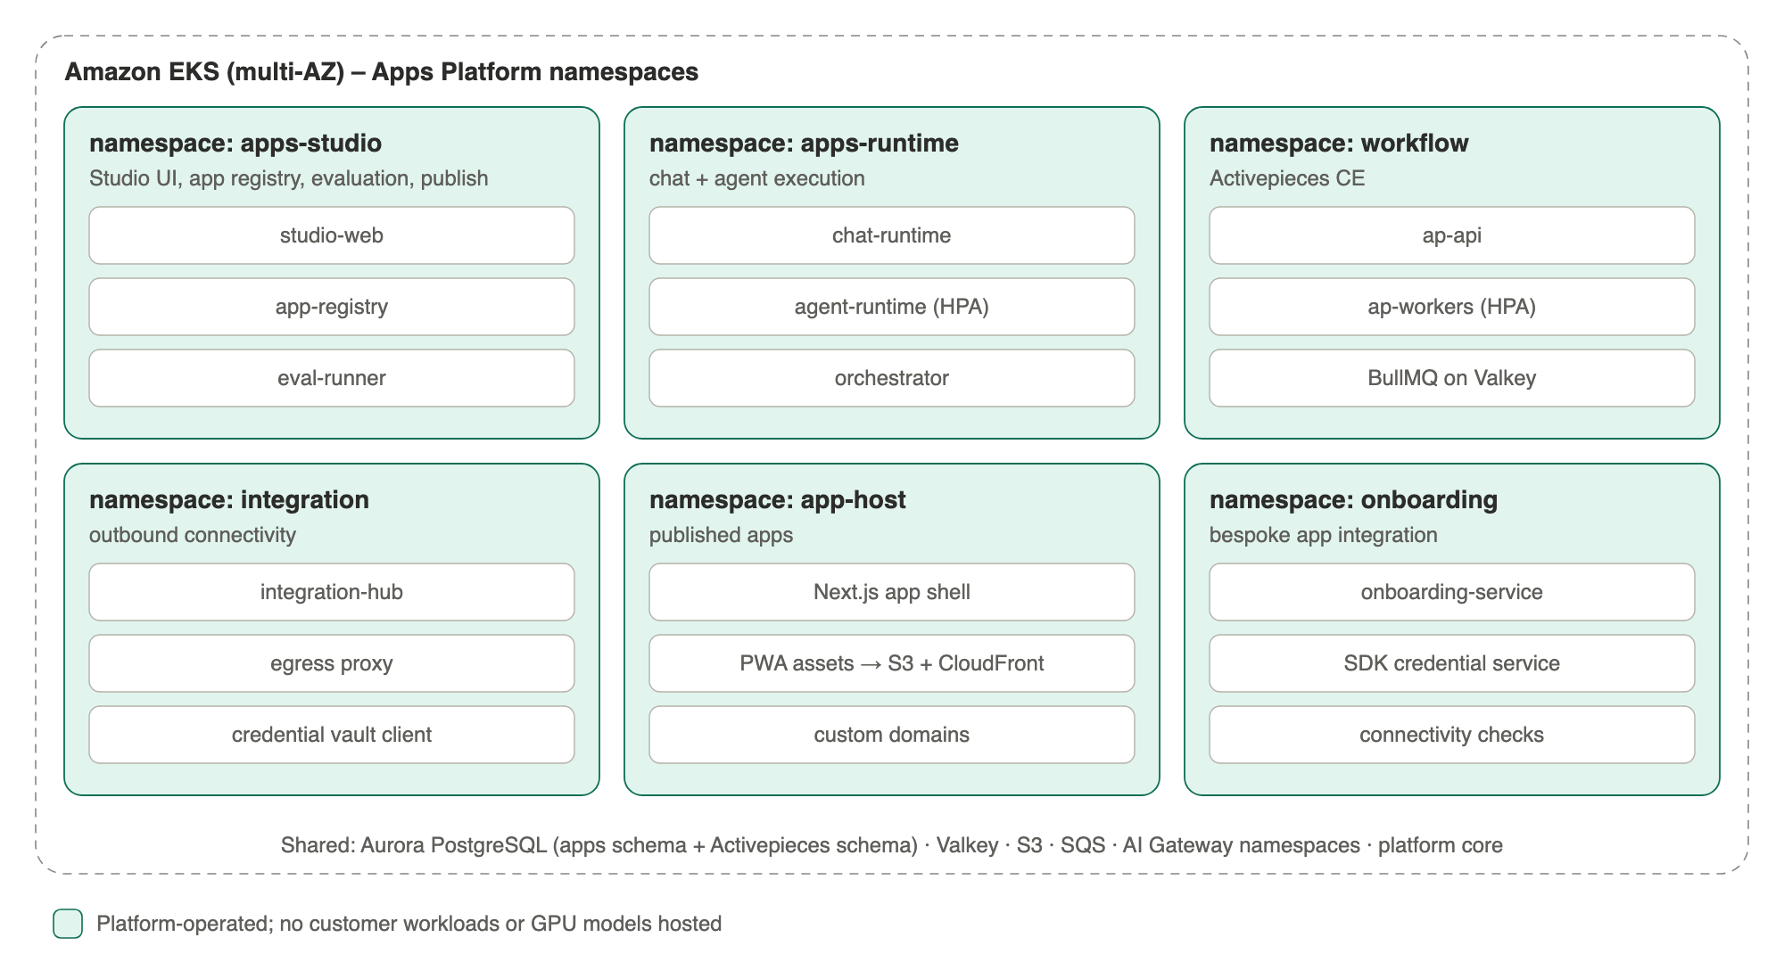
Figure 3 – Apps Platform namespaces on EKS
Namespace | Workloads | Scaling
apps-studio | studio-web, app-registry, eval-runner | HPA on CPU; eval jobs as Kubernetes Jobs
apps-runtime | chat-runtime, agent-runtime, orchestrator | HPA on CPU and queue depth; agent runs dispatched via SQS / NATS
workflow | Activepieces API, workers (sandboxed code steps), BullMQ on Valkey | Workers scale on BullMQ backlog
integration | integration-hub, egress proxy | HPA; egress proxy per AZ
app-host | Next.js app shell; static assets on S3 + CloudFront | CDN-first; shell pods HPA
onboarding | onboarding-service, SDK credential service, connectivity checks | HPA; no customer workloads or models hosted

2.3 App Lifecycle
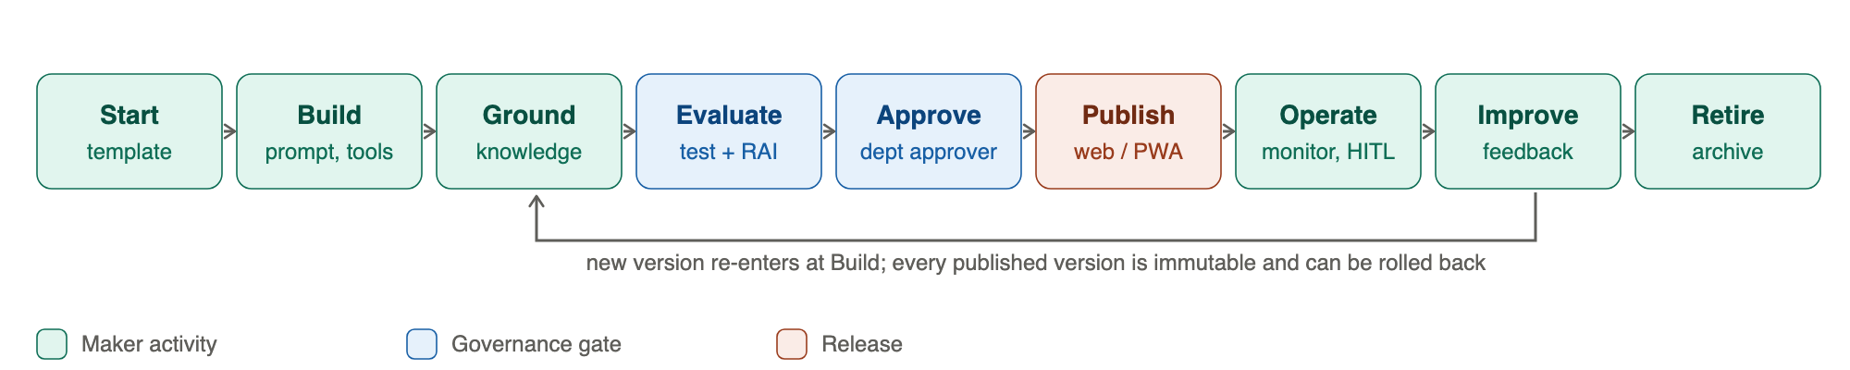
Figure 4 – App lifecycle
Stage | Control
Build | Draft versions are editable; secrets referenced, never embedded
Ground | Knowledge bound by reference; permission filtering inherited from the knowledge service
Evaluate | Mandatory test set per template; groundedness, safety and cost checks; results attached to the version
Approve | Department approver (or tenant admin) signs off; policy can require two approvers for public apps
Publish | Immutable version; canary to a group first; PWA manifest generated; virtual key and budget issued
Operate | Dashboards, alerts, HITL queues, kill switch, budget caps
Improve / Retire | New version from feedback; retire archives data per retention policy and revokes keys

2.4 Key Data Flows
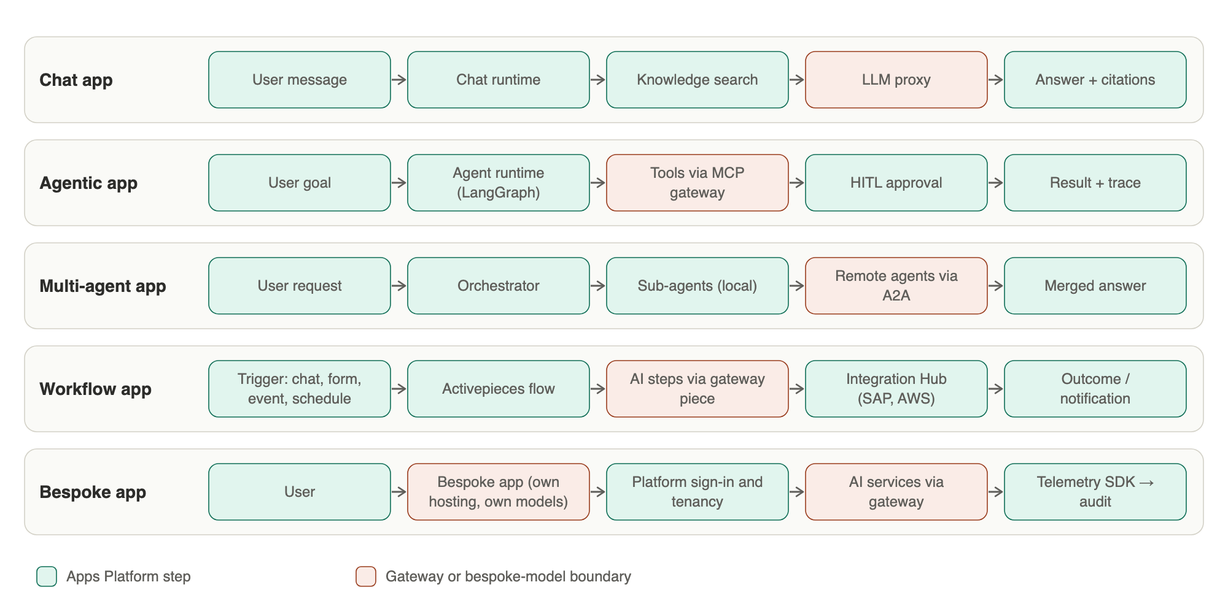
Figure 5 – Runtime flows by app type

How the Runtime Reaches Models and Tools
The Apps Platform runtime and the AI Gateway are separate components (two request segments). Users reach the runtime through the public edge; the runtime then calls the gateway privately for every model, embedding, rerank, knowledge or MCP call. It never calls a model provider or the LLM proxy directly.
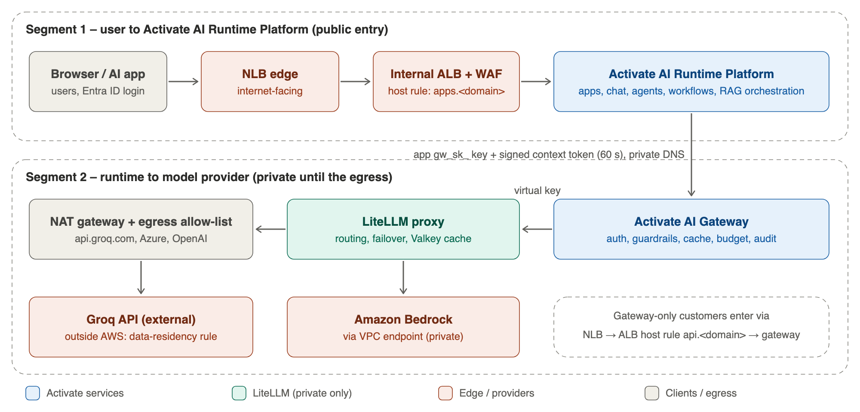
Figure 6 – Request segments: user → runtime, runtime → gateway → LLM proxy → provider
- Identity across the boundary: the runtime sends the app’s gateway key and a 60-second signed context token (org, department, app, hashed user, roles, data classification, conversation and trace IDs). The gateway verifies the signature, rejects replays and checks that the token matches the key’s binding, so the runtime can never act for another tenant.
- Agent loops stay in the runtime: each model call inside a LangGraph loop is a separate gateway request carrying tools, so gateway caching is switched off for it automatically and every step is metered and audited.
- External providers (for example Groq) are selected by model alias at the gateway; whether an app may use them is decided by tenant and data-classification policy, not by the app code.
- Discovery and credentials: the App control plane reads the gateway’s /.well-known/ai-gateway document and capability manifest at start-up and on capabilities.changed events, so new gateway capabilities appear in the Admin console without an Apps Platform release. Registering an app (publish step, BYOA step 3) obtains run-time and build-time credentials from the gateway; the LiteLLM key is never disclosed. Without a gateway grant an app is not served – enforced by the gateway at the network, token and key layers.

Agentic and Multi-agent Execution
- 1. The agent runtime loads the graph from the app version, restores the LangGraph checkpoint for the thread and executes nodes.
- 2. Model calls go to the gateway LLM proxy; tool calls go to the MCP gateway (tool ACLs per app); remote agents are called through the A2A gateway.
- 3. Interrupt nodes create HITL tasks; the run pauses with its checkpoint until a human approves, edits or rejects.
- 4. Each step emits OpenTelemetry spans and usage events tagged with org, department, app, user and run.

Workflow With and Without Chat
- Without chat: a trigger (webhook, schedule, event, form) starts an Activepieces flow; AI steps use the Activate AI Gateway piece; outcomes post to systems through the Integration Hub.
- With chat: the chat runtime maps a user intent to a published workflow (“chat command”), collects inputs conversationally, runs the flow and streams progress back.

2.5 Workflow Builder Integration (Activepieces CE)
Capability | How it is provided | Status in Activepieces CE
LLM steps through the AI Gateway | Built-in Custom (OpenAI-compatible) provider pointed at the gateway; one virtual key per project / app | Available
Per-user cost attribution | Small patch adding org / app / user / run headers to provider calls | Patch (≈ 30 lines)
MCP tools in flows | Community mcp-client piece pointed at the gateway MCP endpoint | Available
MCP and knowledge tools on agents | Agents built in the Activate agent runtime; flows call them via HTTP / A2A | Enterprise-only in Activepieces – not used
Knowledge search | Activate AI Gateway piece (gateway RAG) or Bedrock KB / OpenSearch pieces | Custom pieces (MIT framework)
Activepieces flows as tools for agents | Register Activepieces’ MCP server in the gateway MCP registry | Available
Sign-in, tenancy, audit | Activate platform core in front of an embedded builder | Platform core (EE equivalents not used)

Agent–Workflow Interoperability (LangGraph ↔ Activepieces)
Activepieces runs on the Vercel AI SDK and has no LangGraph or LangChain support, so the two engines are connected through open interfaces governed by the AI Gateway. Two patterns are delivered in Phase 4, alongside the agent runtime.
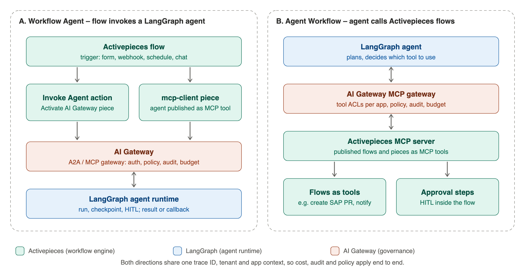
Figure 7 – Workflow Agent and Agent Workflow patterns
Pattern | What it enables | Mechanism | Phase / MD
A. Workflow Agent | An Activepieces flow hands a step to a LangGraph agent (e.g. a form triggers case triage; the flow continues with the agent’s decision) | “Invoke Agent” action in the Activate AI Gateway piece calls the agent runtime through the A2A gateway (synchronous for short runs; asynchronous with a callback webhook or flow wait-point for long runs). Each published agent is also exposed as an MCP tool, callable from the mcp-client piece | Phase 4 – 5 MD †
B. Agent Workflow | A LangGraph agent uses Activepieces flows and 280+ connector pieces as tools (e.g. “create SAP purchase request”, “notify via Teams”), including flows with approval steps | Activepieces MCP server registered in the AI Gateway MCP registry; flows published as MCP tools; tool access granted per app through gateway tool ACLs | Phase 4 – 4 MD †
Design concern | Approach
Identity and tenancy | Calls carry the tenant, department, app and user context; Activepieces project maps to the Activate app
Governance | Every call crosses the AI Gateway: authentication, tool ACLs, Responsible AI policy, budgets
Long-running work | Agents may run for hours (human approval); flows wait on a callback or wait-point rather than holding a connection
Observability | One trace ID propagated across flow → agent → tool → flow; usage and audit attributed to the originating app
Failure handling | Idempotency keys on invoke; retries with back-off; agent checkpoints allow resume; flow error branches handle agent failure
Loops and recursion | Guard against agent → flow → agent cycles with a call-depth limit carried in the context

Knowledge Options for Apps
Option | Storage and search | Best for | Limitations
AI Gateway RAG (default, as-built) | pgvector, hybrid semantic + keyword, re-ranking, tenant and permission filtering; sources fed by Activepieces connector pieces through the ingest API | Suite and (proposed) Apps edition | Requires gateway or Essentials
Bedrock Knowledge Bases | OpenSearch Serverless, managed ingestion from S3 / SharePoint / Confluence | AWS customers, Apps edition | AWS only; custom piece (≈ 3–5 MD)
Customer OpenSearch | Customer domain; hybrid search via neural plugin on managed domains | Customers with existing OpenSearch | Custom piece (≈ 8–12 MD)
Activepieces library | pgvector in Activepieces DB; semantic only; 2,000-character chunks; PDF / DOCX / text | Small, low-risk cases | Upload only; project-level access; OpenAI / Azure / Google / OpenRouter embeddings only; agent search is Enterprise-only

2.6 Bespoke AI App Onboarding (BYOA)
Bespoke AI apps are onboarded, not hosted. The app and its bespoke models keep running in the owner’s environment (customer cloud, data centre or partner hosting); the platform gives it platform core services and AI Gateway services through the SDK and APIs. The platform does not host GPU-driven models.
Step | What the platform does
1. Register | Tenant registers the app (name, owner, endpoints, environment, data classification) and assigns it to a department
2. Connect identity | Entra ID app registration / OIDC client for sign-in; tenant, department and role mapping from the platform core
3. Connect AI services | Gateway virtual key and scopes for the LLM proxy (third-party models), RAG sources, MCP tools and A2A agents; budgets per app
4. Instrument | Telemetry SDK sends traces, usage and audit events; bespoke model calls are reported as app events
5. Verify | Connectivity, identity and policy checks; security review checklist; app appears in the tenant’s app catalogue and launcher
6. Operate and bill | Gateway and platform-service usage metered to the app and department; alerts and audit in the platform consoles
NEA Local POC as the reference: it keeps its own hosting and its ASR, TTS, avatar and LLM models. Onboarding gives it Entra ID sign-in, tenant and department mapping, audit, observability and chargeback, plus governed access to third-party models, knowledge, tools and agents through the AI Gateway. Separately, Phase 2 ports its training-simulator experience as a generic template.

2.7 Components
Component | Responsibility | Technology
studio-web | App Studio, Agent Builder, multi-agent designer, approvals | Next.js, React Flow
app-registry | Apps, versions, manifests, access policies, publish state | FastAPI, PostgreSQL
eval-runner | Evaluation jobs per version | Python jobs; calls gateway evaluation service
chat-runtime | Streaming chat, history, files, citations, feedback | FastAPI (SSE), PostgreSQL, Valkey
agent-runtime | LangGraph execution, checkpoints, interrupts, tool calls | Python, LangGraph, PostgreSQL checkpointer
orchestrator | Supervisor graphs, A2A client, result merging | LangGraph
workflow-engine | Activepieces CE API, workers, sandboxed code | Node.js, BullMQ, Valkey, PostgreSQL
activate-pieces | AI Gateway piece (Ask, Search Knowledge, Call MCP Tool, Invoke Agent, Check Budget), knowledge pieces, HITL bridge | Activepieces pieces framework (TypeScript)
integration-hub | Credential vault, egress proxy, enterprise connectors | FastAPI, Envoy / Squid, KMS / Vault
app-host | App shell, PWA manifests, custom domains | Next.js, S3, CloudFront, ACM
onboarding-service | Bespoke app registration, identity client, gateway key issue, connectivity checks, catalogue entry | FastAPI, PostgreSQL
telemetry-sdk | Traces, usage and audit from onboarded bespoke apps | OpenTelemetry SDK (Python, TypeScript)

2.8 Data Model
Entity | Key relationships | Notes
apps | N : 1 department, organisation | type = chat | agent | multi_agent | workflow | bespoke
app_versions | N : 1 app; 1 : 1 manifest | Immutable after publish; status draft → in_review → approved → published → retired
templates / template_versions | 1 : N apps created from them | Platform or tenant templates
agent_graphs | 1 : 1 app_version (agent types) | Graph JSON + code reference
agent_runs / checkpoints / hitl_tasks | N : 1 app_version, user | LangGraph checkpointer tables; HITL queue
workflow_links | app_version → Activepieces flow id / project id | Activepieces keeps its own schema
deployments / domains | N : 1 app_version | Channel (web, PWA, embed), domain, rollout state
onboarded_apps | N : 1 app | Endpoints, identity client, gateway key reference, telemetry settings, verification status
app_feedback / evaluations | N : 1 app_version | Ratings, test results

2.9 Multi-Tenancy, Isolation and Scalability
- Tenant isolation follows the parent document: row-level security on all Apps Platform tables, per-tenant KMS keys; onboarded bespoke apps are bound to tenant-scoped identity clients and gateway keys.
- Activepieces mapping: one Activepieces project per Activate app (or department); the platform core is the only identity provider; Activepieces queries are always project-scoped.
- Agent scale: agent runs are queued (SQS / NATS); agent-runtime pods pull work, so 1,000 concurrent agents become a backlog that drains at the gateway’s token budget instead of overloading it.
- Noisy neighbours: per-app and per-tenant concurrency limits on agent runs and workflow workers; gateway budgets and rate limits per onboarded app.
- Latency: app shell from CDN; chat streams via SSE from the nearest region; platform overhead target < 200 ms to first token at GA 2.0.

2.10 Availability and Supportability
- Multi-AZ for all runtimes; agent checkpoints make runs resumable after pod failure; workflow runs are retried from BullMQ.
- Releases follow the parent monthly train; Activepieces CE and LangGraph tracked upstream with quarterly upgrades and contract tests.
- App owners get dashboards, alerts and a kill switch; Activate operates the platform in SaaS.

3 Security

3.1 App Security
- Access policy per app version: internal (Entra ID groups), specific users, or public with rate limits and bot protection.
- Published apps use the platform BFF: httpOnly session cookies, CSRF protection, content security policy in the app shell.
- Responsible AI checks apply at the gateway on every third-party call; apps add per-app guardrail profiles and HITL nodes.

3.2 Agent and Workflow Safety
- Tools are granted per app from the MCP registry; high-impact tools require an interrupt (human approval) node.
- Kill switch per app and per agent; budget caps per app enforced by the gateway.
- Activepieces code steps run in its sandbox; outbound calls only through the egress proxy with allow-lists.

3.3 Bespoke App Onboarding Security
- Each onboarded app gets its own identity client and gateway key with least-privilege scopes (models, knowledge sources, tools, agents); keys rotate and can be revoked instantly.
- Default-deny network policies; egress only to the gateway, telemetry endpoint and approved destinations.
- The platform stores no bespoke app code, images or model weights; only data that passes through gateway services is processed under platform policy.

3.4 Integration Security
Runtime to gateway: private network only, app gateway key plus signed context token (section 2.4). The LLM proxy is not reachable from the runtime.
Control plane to gateway: the Admin console manages a tenant’s gateway configuration through the gateway management API using token exchange (gateway-issued, KMS-signed, tenant-bound, short-lived tokens). Build-time credentials for CI, SDK and evaluation pipelines are separate from run-time keys, carry narrower scopes and budgets, and auto-rotate.
Enterprise connections use short-lived credentials (AWS STS with external ID, Azure workload identity federation, SAP OAuth) issued by the Integration Hub; secrets are vaulted and scoped to one app.

4 Technical Debt and Exceptions to Standards
Item | Position
Activepieces Enterprise features (embedded builder branding, SSO, piece access control, saved agents with MCP / knowledge tools) | Not used; replaced by the platform core and the Activate agent runtime. Licence track handled separately
LangGraph Platform (commercial deployment product) | Not used; Activate runs the MIT LangGraph library in its own runtime
Activepieces library limitations | Kept only as a fallback knowledge option

5 Assumptions, Dependencies and Open Items

5.1 Assumptions and Dependencies
- Delivery follows the Activate phased roadmap (Appendices A and B): the Apps Platform foundation starts in Phase 0 alongside the gateway resilience work; the GRL@PA app (Phase 1) and the NEA Training Simulator (Phase 4) are ported as generic, template-driven apps; LangGraph agentic workflows and an agentic batch-processing app arrive in Phase 2, and the agent runtime, templates and agent–workflow interoperability in Phase 4.
- Activepieces CE remains MIT-licensed for the modules used.
- Effort is expressed in man-days (MD) with a 20% buffer on every line.

5.2 Open Items
# | Open item | Owner
1 | Include basic knowledge search in Gateway Essentials for the Apps edition (recommended). | Product
2 | Initial template catalogue for GA 1.0 (proposed in Appendix D) and target industries. | Product
3 | Whether to license the Activepieces white-label embedded builder or rely on the Activate Studio shell. | Product / Legal
4 | Onboarding SDK languages and the minimum integration level for bespoke apps (sign-in only, or full gateway use), with NEA Local POC as pilot. | Architecture
5 | Telemetry contract for BYOA apps (mandatory fields, sampling). | Architecture
6 | Embedding mode for gateway configuration in the Admin console: native rendering from the capability manifest (recommended) or micro-frontend of the gateway admin console. | Architecture

Appendix A Phased Roadmap
Activate phased-deliverable format. AI Apps Platform view: apps features plus its share of shared-core and continuous design and testing effort. The combined view is in the Activate AI Platform Overall Roadmap.
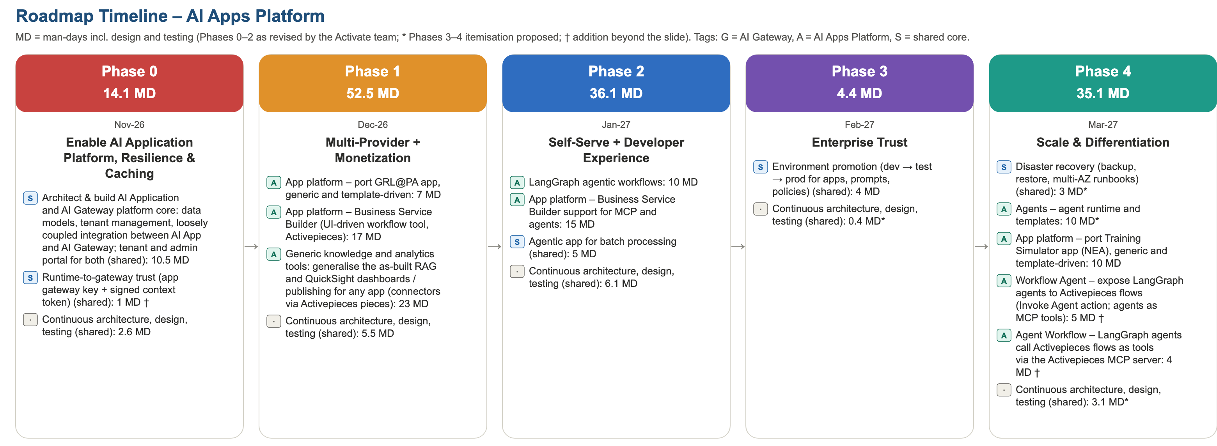
Figure 8 – Phased roadmap, AI Apps Platform view (* = proposed itemisation; † = addition beyond the slide)

Phase 0 – Enable AI Application Platform, Resilience & Caching (Nov-26)
# | Feature | Product | Design | Development | Testing | Product mgmt | Total MD
1 | Architect & build AI Application and AI Gateway platform core: data models, tenant management, loosely coupled integration between AI App and AI Gateway; tenant and admin portal for both | Shared core | 2 | 6.5 | 2 | – | 10.5
2 | Runtime-to-gateway trust (app gateway key + signed context token) † | Shared core | 0 | 0.7 | 0.2 | – | 0.9
3 | AI App–AI Gateway integration contract: /.well-known/ai-gateway discovery document and authenticated capability manifest (sections, routes, scopes, JSON Schemas) for runtime discovery; tenant onboarding as the gateway grant † | Shared core | 0.5 | 1 | 0.5 | – | 2
4 | Continuous architecture, design, testing | Shared (continuous) | 1.3 | 0 | 1.3 | – | 2.6
 | Product management (10% of phase effort) | Programme | – | – | – | 1.6 | 1.6
 | Phase total |  | 3.8 | 8.2 | 4 | 1.6 | 17.6

Phase 1 – Multi-Provider + Monetization (Dec-26)
# | Feature | Product | Design | Development | Testing | Product mgmt | Total MD
1 | App platform – port GRL@PA app, generic and template-driven | AI Apps | 0 | 7 | 0 | – | 7
2 | App platform – Business Service Builder (UI-driven workflow tool, Activepieces) | AI Apps | 4 | 9 | 4 | – | 17
3 | Generic knowledge and analytics tools: generalise the as-built RAG and QuickSight dashboards / publishing for any app (connectors via Activepieces pieces) | AI Apps | 2 | 16 | 5 | – | 23
4 | Continuous architecture, design, testing | Shared (continuous) | 2.1 | 1.4 | 2.1 | – | 5.6
 | Product management (10% of phase effort) | Programme | – | – | – | 5.3 | 5.3
 | Phase total |  | 8.1 | 33.4 | 11.1 | 5.3 | 57.9

Phase 2 – Self-Serve + Developer Experience (Jan-27)
# | Feature | Product | Design | Development | Testing | Product mgmt | Total MD
1 | LangGraph agentic workflows | AI Apps | 0 | 7 | 3 | – | 10
2 | App platform – Business Service Builder support for MCP and agents | AI Apps | 0 | 10 | 5 | – | 15
3 | Agentic app for batch processing | Shared core | 0 | 3.5 | 1.5 | – | 5
4 | Continuous architecture, design, testing | Shared (continuous) | 2 | 1.3 | 2.7 | – | 6
 | Product management (10% of phase effort) | Programme | – | – | – | 3.6 | 3.6
 | Phase total |  | 2 | 21.8 | 12.2 | 3.6 | 39.6

Phase 3 – Enterprise Trust (Feb-27)
# | Feature | Product | Design | Development | Testing | Product mgmt | Total MD
1 | Environment promotion (dev → test → prod for apps, prompts, policies) | Shared core | 0 | 4 | 0 | – | 4
2 | Build-time and run-time app credentials (client credentials for CI, SDK and evaluation pipelines), gateway token exchange for the App control plane acting for a tenant administrator, gateway events (webhooks / EventBridge) † | Shared core | 0.5 | 2 | 0.5 | – | 3
3 | Continuous architecture, design, testing * | Shared (continuous) | 0.1 | 0 | 0.2 | – | 0.3
 | Product management (10% of phase effort) | Programme | – | – | – | 0.7 | 0.7
 | Phase total |  | 0.6 | 6 | 0.7 | 0.7 | 8

Phase 4 – Scale & Differentiation (Mar-27)
# | Feature | Product | Design | Development | Testing | Product mgmt | Total MD
1 | Disaster recovery (backup, restore, multi-AZ runbooks) * | Shared core | 0 | 3 | 0 | – | 3
2 | Agents – agent runtime and templates * | AI Apps | 0 | 10 | 0 | – | 10
3 | App platform – port Training Simulator app (NEA), generic and template-driven | AI Apps | 0 | 7 | 3 | – | 10
4 | Workflow Agent – expose LangGraph agents to Activepieces flows (Invoke Agent action; agents as MCP tools) † | AI Apps | 0 | 4 | 1 | – | 5
5 | Agent Workflow – LangGraph agents call Activepieces flows as tools via the Activepieces MCP server † | AI Apps | 0 | 3 | 1 | – | 4
6 | Continuous architecture, design, testing * | Shared (continuous) | 1.2 | 0 | 1.9 | – | 3.1
 | Product management (10% of phase effort) | Programme | – | – | – | 3.5 | 3.5
 | Phase total |  | 1.2 | 27 | 6.9 | 3.5 | 38.6

Appendix B Resource Requirement by Phase
Man-days (MD) by discipline. Development = feature effort from the roadmap slide; design and testing = the slide’s continuous architecture, design and testing effort (40% / 60%); product management = 10% added on top of each phase.

B.1 AI Apps Platform Resource Requirement
Discipline | Phase 0 (Nov-26) | Phase 1 (Dec-26) | Phase 2 (Jan-27) | Phase 3 (Feb-27) | Phase 4 (Mar-27) | Total MD
Design (architecture, solution and UX design) | 3.8 | 8.1 | 2 | 0.6 | 1.2 | 15.7
Development | 8.2 | 33.4 | 21.8 | 6 | 27 | 96.4
Testing (QA, automation, performance, security) | 4 | 11.1 | 12.2 | 0.7 | 6.9 | 34.9
Product management | 1.6 | 5.3 | 3.6 | 0.7 | 3.5 | 14.7
Total | 17.6 | 57.9 | 39.6 | 8 | 38.6 | 161.7
Indicative team (FTE over 20 working days) | 0.9 | 2.9 | 2 | 0.4 | 1.9 | 1.6

B.2 Slide Reconciliation
Phase | Slide header MD | Itemised MD used | Difference | Note
Phase 0 | 50 | 69 | 19 | Revised by the Activate team: platform core now includes tenant management and the tenant and admin portal for both products; per-feature testing added. Plus † LiteLLM tenant integration build (8 MD) and runtime–gateway trust (2 MD). Plus † from the RESPONSIBLE-AI-ENTERPRISEREADY roadmap review (2 October 2026): AI App–AI Gateway integration contract (4 MD)
Phase 1 | 52 | 82 | 30 | Revised by the Activate team: per-feature testing; generic knowledge and analytics tools moved in (23 MD, previously a Horizon 1 addition). Plus † gateway admin console – Proxy Manager (6 MD, port of the RESPONSIBLE-AI reference implementation)
Phase 2 | 50 | 70.5 | 20.5 | Revised by the Activate team: LangGraph agentic workflows and an agentic batch-processing app replace the NEA port (moved to Phase 4) and the tenant portal (moved to Phase 0). Plus † as-built cache hardening (4.5 MD). Plus † scoped gateway settings (8 MD), guided configuration (5 MD) and LiteLLM capability discovery (4 MD)
Phase 3 | 40 | 55 | 15 | Breakdown proposed (*); environment promotion 8 MD per the Activate team; prompt-injection detection revised to 4 MD (LiteLLM built-in detection). Plus † testing uplift (6 MD). Plus † app credentials, token exchange and gateway events (6 MD) and admin audit view (2 MD)
Phase 4 | 30 | 53 | 23 | Breakdown proposed (*); semantic routing revised to 4 MD and re-ranking to 2 MD (LiteLLM Auto Router and /rerank); NEA port moved in (10 MD). Plus † agent–workflow interoperability (9 MD). Plus † configuration copilot (8 MD)

B.3 Backlog After Phase 4 (AI Apps Platform and shared core)
Capability not covered by Phases 0–4 | Product | Indicative MD
Critical security fixes from the as-built review (secret rotation and history purge, enforced fail-closed RLS, CI secret scanning) – recommended to add to Phase 0 | Shared core | 4
Identity: multi-tenant Entra federation (External ID, other IdPs), SCIM, group-to-role mapping – extends the as-built Entra ID login and RBAC/ABAC | Shared core | 10
EKS + Helm packaging; on-premises and air-gapped bundles | Shared core | 55
Scale to 1,000 users / agents (asynchronous usage and audit writers, Valkey counters, load tests) | Shared core | 17.5
Agent Builder UI (graph editor + code mode) and multi-agent orchestrator | AI Apps | 60
Publishing (PWA, custom domains), evaluation gate and approvals | AI Apps | 35
Integration Hub (credential vault, egress proxy, AWS / Azure / SAP connectors) | AI Apps | 40
Activate AI Gateway piece and knowledge pieces (Bedrock KB, OpenSearch; connector wiring already in the Phase 1 generic knowledge tool) | AI Apps | 10
Bespoke AI app onboarding (registration, SDK, identity and gateway integration, telemetry) | AI Apps | 30
Total (indicative) |  | 261.5
Phases 0–4 need about 161.7 MD for the AI Apps Platform share (including product management), of which 5.5 MD are the Apps share of the additions from the RESPONSIBLE-AI roadmap review. The backlog adds about 261.5 MD (indicative, AI-assisted, including 20% buffer) to reach the Apps vision in Appendix C. Shared-core items are split 50/50 with the AI Gateway.

Appendix C Full Product Vision – Apps Release Train and Effort (Reference)
Reference only: the full Apps Platform vision as a release train with manual and AI-assisted effort. Phases 0–4 (Appendices A and B) are the committed first subset; the backlog in Appendix B.3 bridges to this vision.
Apps Platform workstreams within the parent release train (two two-week sprints per monthly release).
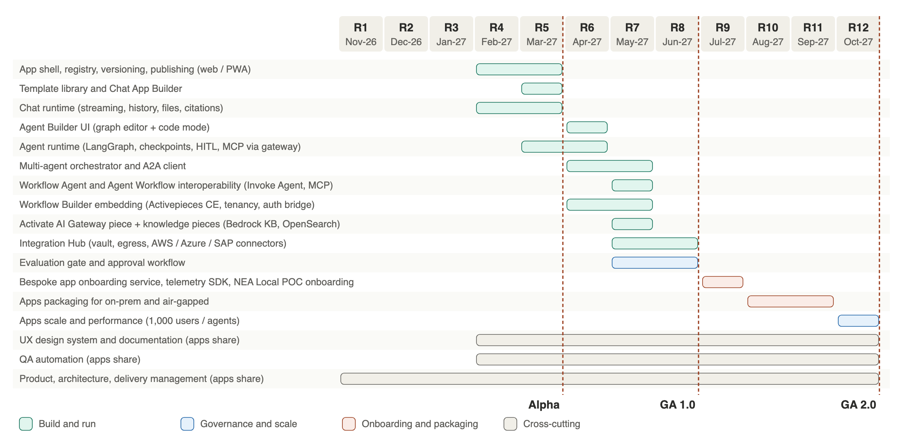
Figure 9 – Apps Platform vision release train
Release | Month | Apps Platform scope | Exit criteria
R1–R3 | Nov-26 – Jan-27 | Platform core and gateway foundations (parent document); Apps architecture spikes, app manifest schema, UX design system | Manifest schema approved; design system v1
R4 | Feb-27 | App shell, registry, versioning; chat runtime | Internal chat app runs end to end
R5 | Mar-27 | Template library, Chat App Builder, publish as web / PWA – Alpha | First templated chat app published by a maker
R6 | Apr-27 | Agent Builder and runtime (LangGraph, HITL); multi-agent orchestrator alpha; Activepieces embedding | Agentic app with approval node in production pilot
R7 | May-27 | Activate AI Gateway and knowledge pieces; Integration Hub; evaluation gate and approvals; A2A client | Workflow with and without chat calling SAP / AWS
R8 | Jun-27 | Hardening, pen test – GA 1.0 | First paying tenants
R9 | Jul-27 | Bespoke app onboarding service and telemetry SDK; NEA Local POC onboarded; PWA polish | NEA POC using platform sign-in, audit and gateway
R10–R11 | Aug-27 – Sep-27 | Apps packaging for on-prem and air-gapped | Offline install of Apps Platform verified
R12 | Oct-27 | Scale to 1,000 users / agents per tenant – GA 2.0 | Load and soak tests at SLO

C.2 Vision Effort Estimate and Resources
Man-days (MD) for the Apps Platform scope of the roadmap. A 20% buffer is added to every line item. Shared platform core and AI Gateway effort is in the parent document.

C.2.1 Manual Coding
# | Workstream | Releases | Base MD | +20% | Total MD
1 | App shell, registry, versioning, publishing (web / PWA) | R4–R5 | 60 | 12 | 72
2 | Template library and Chat App Builder | R5 | 70 | 14 | 84
3 | Chat runtime (streaming, history, files, citations) | R4–R5 | 50 | 10 | 60
4 | Agent Builder UI (graph editor + code mode) | R6 | 70 | 14 | 84
5 | Agent runtime (LangGraph, checkpoints, HITL, MCP via gateway) | R5–R6 | 80 | 16 | 96
6 | Multi-agent orchestrator and A2A client | R6–R7 | 50 | 10 | 60
7 | Workflow Agent and Agent Workflow interoperability (Invoke Agent, MCP) | R7 | 15 | 3 | 18
8 | Workflow Builder embedding (Activepieces CE, tenancy, auth bridge) | R6–R7 | 60 | 12 | 72
9 | Activate AI Gateway piece + knowledge pieces (Bedrock KB, OpenSearch) | R7 | 30 | 6 | 36
10 | Integration Hub (vault, egress, AWS / Azure / SAP connectors) | R7–R8 | 60 | 12 | 72
11 | Evaluation gate and approval workflow | R7–R8 | 40 | 8 | 48
12 | Bespoke app onboarding service, telemetry SDK, NEA Local POC onboarding | R9 | 40 | 8 | 48
13 | Apps packaging for on-prem and air-gapped | R10–R11 | 40 | 8 | 48
14 | Apps scale and performance (1,000 users / agents) | R12 | 30 | 6 | 36
15 | UX design system and documentation (apps share) | R4–R12 | 50 | 10 | 60
16 | QA automation (apps share) | R4–R12 | 55 | 11 | 66
17 | Product, architecture, delivery management (apps share) | R1–R12 | 75 | 15 | 90
 | Total |  | 875 | 175 | 1050

C.2.2 AI Coding Agents with Architect Oversight
# | Workstream | Releases | Base MD | +20% | Total MD
1 | App shell, registry, versioning, publishing (web / PWA) | R4–R5 | 30 | 6 | 36
2 | Template library and Chat App Builder | R5 | 35 | 7 | 42
3 | Chat runtime (streaming, history, files, citations) | R4–R5 | 25 | 5 | 30
4 | Agent Builder UI (graph editor + code mode) | R6 | 35 | 7 | 42
5 | Agent runtime (LangGraph, checkpoints, HITL, MCP via gateway) | R5–R6 | 40 | 8 | 48
6 | Multi-agent orchestrator and A2A client | R6–R7 | 25 | 5 | 30
7 | Workflow Agent and Agent Workflow interoperability (Invoke Agent, MCP) | R7 | 8.3 | 1.7 | 10
8 | Workflow Builder embedding (Activepieces CE, tenancy, auth bridge) | R6–R7 | 33 | 6.6 | 39.6
9 | Activate AI Gateway piece + knowledge pieces (Bedrock KB, OpenSearch) | R7 | 16.5 | 3.3 | 19.8
10 | Integration Hub (vault, egress, AWS / Azure / SAP connectors) | R7–R8 | 33 | 6.6 | 39.6
11 | Evaluation gate and approval workflow | R7–R8 | 22 | 4.4 | 26.4
12 | Bespoke app onboarding service, telemetry SDK, NEA Local POC onboarding | R9 | 24 | 4.8 | 28.8
13 | Apps packaging for on-prem and air-gapped | R10–R11 | 26 | 5.2 | 31.2
14 | Apps scale and performance (1,000 users / agents) | R12 | 21 | 4.2 | 25.2
15 | UX design system and documentation (apps share) | R4–R12 | 30 | 6 | 36
16 | QA automation (apps share) | R4–R12 | 33 | 6.6 | 39.6
17 | Product, architecture, delivery management (apps share) | R1–R12 | 67.5 | 13.5 | 81
 | Total |  | 504.3 | 100.9 | 605.2

C.3 Summary and Team
Approach | Base MD | With 20% buffer | Average FTE (R4–R12, 9 months) | Saving
Manual coding | 875 | 1050 | 5.8 | –
AI coding agents with architect oversight | 504.3 | 605.2 | 3.4 | 42%
Role (Apps squad) | Manual (FTE) | AI-assisted (FTE)
Tech lead (apps) | 1 | 1
Backend engineers (Python agents, FastAPI) | 2 | 0.75
TypeScript engineer (Activepieces, pieces, app shell) | 1 | 0.5
Frontend engineer (Studio, builders) | 1 | 0.5
Platform engineer (EKS, onboarding) | 0.5 | 0.5
QA automation | 0.5 | 0.25
UX designer | 0.5 | 0.5
Total | 6.5 | 4.0
The Apps squad is part of the parent team plan (11.8 FTE manual / 8.2 FTE AI-assisted at peak); product owner and architect are shared with the gateway squad.

Appendix D Initial Template Catalogue (GA 1.0)
Template | Type | Typical users | Key tools / knowledge
GRL@PA reporting assistant (ported in Phase 1) | Chat + dashboards | Analysts, managers | Natural-language reports and dashboards over operational data (MCP)
Training simulator (NEA, ported in Phase 4) | Agentic | Trainers, officers | Role-play personas, scenarios, assessment; bespoke speech and avatar models stay with the NEA app (not hosted on the platform)
Policy and HR assistant | Chat | All staff | HR policies (RAG), leave system (read)
IT helpdesk | Agentic | Staff, IT | Knowledge base, ServiceNow ticket create (HITL)
Citizen / customer enquiry | Chat | Public | FAQ knowledge, escalation workflow
Case triage | Agentic | Case officers | Case records, classification, routing, approval node
Report author | Agentic | Analysts | Data sources via MCP, document templates, review node
Procurement assistant | Multi-agent | Procurement | Vendor search, policy check, SAP purchase request (HITL)
Meeting-to-actions | Workflow + chat | Managers | Transcript in, tasks out to Teams / Planner
Document review | Agentic | Legal, compliance | Clause library (RAG), redline output, approval node

